## The Chevron Flush Median Tool

This tool also works like a polygon, with the first click forming the tip of the chevron.

**To place the chevron flush median tool:**

* Select the Chevron Flush Median tool from the Markings tab in the Tools Palette
* Your first click will be the top point of the shape (in the direction of the chevron)
* Then click for all other consecutive points
* Right click to finish
* 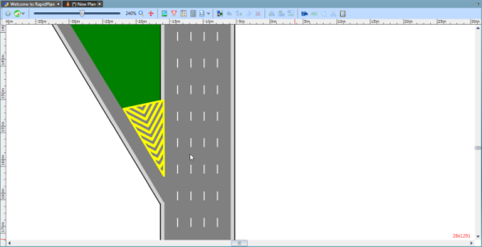
* Chevron_Flush_Median_tool